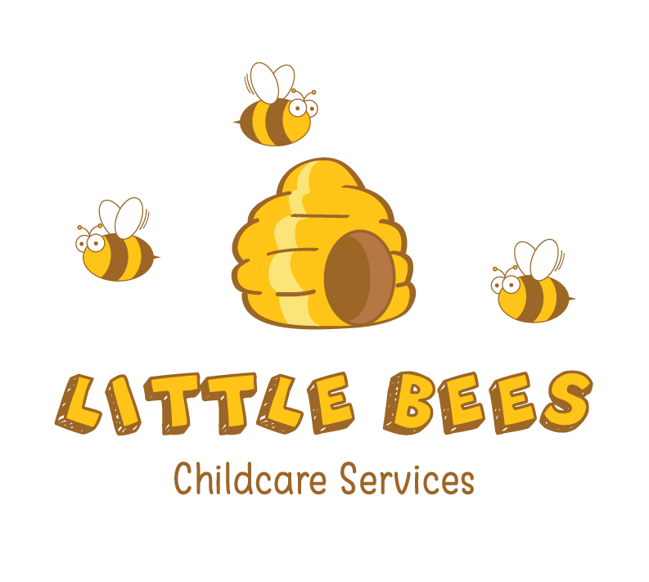

After School Club
Parents’ Handbook

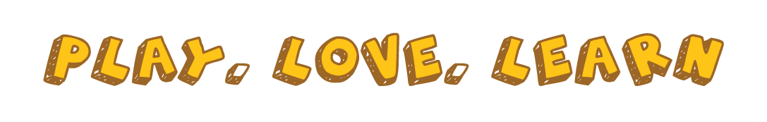

About Our Club
Little Bees Childcare Services is registered with OFSTED and is based in Westergate. Our after-school club is open from 3:00pm (school pick up) until 5:30pm weekdays, during term time. Our after-school club is based at Westergate Methodist Church Hall, on Westergate Street. The premises is made up a large hall with access to a large outdoor area including a large field.
Aims
At Little Bees, we aim to provide a safe and secure and relaxed environment, offering a range of activities to reflect the interests of the children in our care.
What we offer
Our Club follows the Playwork Principles, so the children are free to choose activities and resources as they wish. There will always be a selection of activities and resources available, including dressing up, home corner, craft, board games, construction, physical play, cookery and reading. In addition, other resources are available for the children to select from our equipment library.
What we provide
The food we provide at Little Bees is not intended as a substitute for a main evening meal. We provide healthy snacks, including fresh fruit and vegetables. We promote independence by encouraging the children to prepare their own snacks, and to clear away after themselves. Fresh drinking water is available at all times. We meet individual dietary requirements and parental preferences wherever possible. We recognise the importance of healthy nutrition for children that is delivered in a calm, friendly setting. Snack is available at 4pm and is to be consumed whilst sitting at the snack table.
Staffing
Little Bees is staffed by a manager and qualified teacher/childminder Kirsty, deputy manager/childminder Beth and assistants Jo, Rebecca and Sue. In addition, we have volunteer staff. Our aim is to provide a smooth transition between school and club. All of our staff have significant experience of working with children and undertake professional development training. All staff members have appropriate DBS checks and are first aid trained. We maintain a staff/ child ration of 1:6 for children under the age of 8 and 1:10 for children over the age of 8. Children in Early Years Education (reception class) will have a named Key Worker. The Special Education Needs Co-ordinators and Child Protection Officers are Kirsty Trent and Beth Austin.

Organisation
Little Bees Childcare Services is run as a private business. We enjoy a close working relationship with Aldingbourne Primary School in order to ensure continuity of care, and to maintain good communication links.
Policies and procedures
Little Bees has clearly defined policies and procedures. Key points of the main policies are included in this Handbook. Copies of the full policies are kept at the Club and are available for parents to consult at all times.
Terms and Conditions
Admissions
Little Bees aims to be accessible to children and families from all sections of our local community. Admission to the club is organised by the Manager and we use a waiting list system when the need arises. The waiting list will be operated on a first come-first served basis, with the exception of siblings who will have priority for the same days as a sibling already attending. See our Admissions and Fees Policy for more details. We require a completed registration form for your child before they can attend the club. This information will be treated as confidential and will be stored appropriately. Re-enrolment for September is automatic unless the required notice is given.
Payment of fees
The current fees are £17.50 per child per session.
Invoices are sent out upon registration and fees are divided into equal payments for the remainder of the term. For example, if your child starts in September, the total number of sessions your child will attend is added up, and divided by 12. This means the fees will remain the same every month until the final payment in August. If your child leaves mid-way through term, there may be an additional payment required due to the total number of sessions taken being different to the amount paid.
Fees are payable in advance by the first of each month, by bank transfer. Tax-Free Childcare and Childcare Vouchers are accepted.
The price per session per child applies to all children. This is payable including when your child is sick, or on holiday. We do not charge for bank holidays or INSET days. Please ensure that fees are paid promptly. Non-payment for more than one month may result in your place being terminated.
Changes to days and cancelling your place
You must give us one month’s notice of termination, or of changes in attendance. If you need to change the days that your child attends, please contact the Manager. We try to accommodate such changes wherever possible.
Temporary changes
Please remember that we need to know if your child will not be attending Little Bees for any reason. Even if you have informed your child’s school, you still need to notify us as the school does not pass this information on to us.
Induction
You and your child are welcome to visit Little Bees before your child’s first day, to familiarise yourselves with the setting and to help your child settle in. During your child’s first session, time will be set aside for an induction. The induction will include running through our golden rules and routines and introducing your child to the staff and children. Another child will usually be allocated to act as your child’s buddy for the first few sessions.
Arrivals and departures
Our staff collect children from Aldingbourne Primary School and escort them to the club. We will keep a register of all children who attended each day. We expect that your child will normally be collected by the people you have named on the registration form. If you need a different person to collect your child on a particular day, you must notify us in advance. We will not release your child into the care of a person unknown to us without your authorisation.
Little Bees finishes at 5;30pm. If you are delayed for any reason, please let us know. A late payment fee of £6.50 per 15 minutes will be charged if you collect your child after the club has closed. If your child remains uncollected at 6pm (30 minutes after Little Bees closes) and you have not warned us you will be delayed, and we have been unable to reach you or any of your emergency contacts, we will follow our Uncollected Children Policy and contact the Social Care team.
Child protection
We are committed to building a ‘culture of safety’ in which the children in our care are protected from abuse and harm. Any suspicion of abuse is promptly and appropriately responded to. We comply with local and national child protection procedures and ensure that all staff are appropriately trained. For more details, please see our Safeguarding Policy.
Equal opportunities
Our after-school club provides a safe and caring environment, free from discrimination, for everyone in our community including children with additional needs. We respect the different racial origins, religions, cultures and languages in a multi-ethnic society so that each child is valued as an individual without racial or gender stereotyping. We will challenge inappropriate attitudes and practices. We will not tolerate any form of racial harassment.
Special needs
We make every effort to accommodate and welcome any child with special needs. We will work in liaison with parents or carers and relevant professionals to fully understand your child’s specific requirements. We will endeavour to accommodate all children of all abilities, whilst working within Little Bees’ limitations. Each case will be considered individually and risk-assessed to ensure everyone’s safety. For more details on equal opportunities and special needs, see our Equality Policy.
General Information
Behaviour (children)
Children and staff have created golden rules for acceptable behaviour whilst at Little Bees. These are displayed at the club for everyone to see. We have a clear Behaviour Management Policy, a copy of which is distributed to all parents and carers: Little Bees promote an atmosphere of care, consideration and respect for everyone attending: children, staff and visitors. We encourage appropriate behaviour through: praise for good behaviour; emphasis on cooperative play and sharing; talking to children with the courtesy that we expect from them and engaging children in activities. Little Bees has procedures for dealing with unacceptable behaviour. If your child is violent, or if their behaviour poses an immediate danger to themselves or others, we will require you to collect them from Little Bees immediately. In exceptional circumstances, and only when all other attempts at behaviour management have failed, we reserve the right to permanently exclude a child from Little Bees. See our Suspensions and Exclusion Policy for full details.
Behaviour (adults)
We will not tolerate from any person, whether a parent, carer, or visitor: bullying; aggressive, confrontational or threatening behaviour; or behaviour intended to result in conflict. Little Bees is a place of safety and security for the children who attend and the staff who work here, and we reserve the right to ban anyone exhibiting inappropriate behaviour from our premises.
Illness
We are unable to care for children who are unwell. If your child becomes unwell whilst at Little Bees we will contact you and ask you to make arrangements from them to be collected. Please inform the Manager of any infectious illness your child contracts. If your child has had sickness or diarrhoea please do not send them to Little Bees for 48 hours after the illness has ceased. For full details see our Illness and Accident Policy.
Accidents and first aid
Every precaution is taken to ensure the safety of the children at all times, and Little Bees Childcare Services is fully insured. Our staff are trained in first aid and a first aid kit is kept on the premises. If your child has an accident whilst in our care, you will be informed when you collect your child and a form will need to be signed. For full details see our Illness and Accidents Policy.
Medication
Please let the Manager know if your child is taking prescribed medication. If your child needs to take medicine whilst at the club you will need to complete a medication permission form. See our Administering Medication Policy for more details.
Complaints procedure
If you have any queries, comments or need to discuss any matters concerning your child, please feel free to speak to your child’s key person, the Manager, or any other member of staff. Verbal complaints will be discussed by all staff and actioned. All written complained will be acknowledged within five working days of receipt and a full written response will be given within 28 days. A full copy of our Complaints Policy is available on request.
Privacy Notice
At Little Bees Childcare Services, we respect the privacy of the children attending and the privacy of their parents and carers. The personal information that we collect about you and your child is used only to provide appropriate care for them, maintain our service to you, and communicate with you effectively. Our legal basis from processing the personal information relating to you and your child is so that we can fulfil our contract with you. Any information that you provide is kept secure. Data that is no longer required is erased after your child has ceased attending Little Bees. We will only share personal information about you or your child with another organisation if we have a safeguarding concern about your child, are required to by government bodies or law enforcement agencies or have obtained your prior permission.
You have the right to ask to see the data that we have about yourself or your child. If you have a complaint about data, you can refer us to the Information Commissioner’s Office (ICO).
Pledge to parents
We value our relationship with parents/ carers and are committed to working in partnership with you to provide top quality play and care for your children. We will:
-Welcome you at all times to discuss our work, have a chat or take part in our activities
-Keep you informed of opening times, fees and charges, programmes of activities, menus and procedures
-Be consistent and reliable to enable you to plan with confidence and peace of mind
-Share and discuss your child’s achievements, experiences, progress and friendships
-Be available to discuss decisions about running the club
-Ask your permission for outings and special events
-Listen to your views and concerns to ensure that we continue to meet your needs.

Contact information
Little Bees Childcare Services
12 Lamorna Gardens
Westergate
PO20 3RL
Kirsty 07810487912

