ALDINGBOURNE PRIMARY SCHOOL
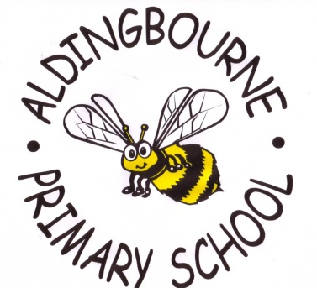
Westergate Street
Westergate
Chichester
West Sussex
PO20 3QR
Headteacher: Miss E Webster, B.Ed (Hons) Tel: 01243 542913
Fax: 01243 544425
e-mail: office@aldingbourne.w-sussex.sch.uk
www.aldingbourneprimaryschool.co.uk
4th January 2021

To my wonderful parents and children,

Tonight, I am so devastated that our amazing community school must once again shut its doors to the majority of our fantastic children.

At 8.00pm, Boris Johnson made the announcement that all schools must close for all children except children of keyworkers and those children who are deemed vulnerable. These are children with a social worker or an EHCP (Educational Health Care Plan). A full list of those eligible can be found at
www.gov.uk/government/publications/coronavirus-covid-19-maintaining-educational-provision/guidance-for-schools-colleges-and-local-authorities-on-maintaining-educational-provision

At this point in my parent mail I must stress the importance of trying to work together to limit the spread of this vile virus and I am asking that if you have the capacity to keep your child at home, you do so. If we want to get over the worst, we need to act responsibly. I fully understand that some parents are critical workers and need to work but if you do have other options for childcare, I am asking that you consider these, before sending your child to school.

Tomorrow all staff will be working to organise and set up our school’s remote learning platform. This will begin on Wednesday 6th January. We will be checking that all parents have and can successfully log in to their Seesaw or Tapestry account. Mrs. Higgo and Mrs. Johnson may need to contact you to check your passwords work.

This is a very tricky time for everybody and I am asking that we all work together to keep each other safe. Closing schools is a huge decision by the Government and it has been implemented for a reason. This is the only way we are going to contain the virus and get our country back to normal. Please make every effort to keep your children at home and avoid any unnecessary risk and let’s stop the virus from spreading!

So finally, if you are a key worker and have no other option for child care, I look forward to seeing you tomorrow and please remember to follow all the Government guidelines as well as the ones set out by the school earlier today. I have listed them below.

- Children will be kept in their classroom bubbles to ensure that there is limited cross over with regards teachers and children.
- All parents must wear masks when dropping off and collecting their children from school.
- When collecting children, parents need to be more vigilant at practising social distancing whilst waiting on the playground.
- Ventilation is a key factor to ensuring classroom areas are safe so please make sure your children are wrapped up nice and warm.
- We ask that parents are more cautious than normal with regards illness – please keep children at home if they are feeling unwell.
- No after-school clubs until further notice.
- Staff will be following the school’s Risk Assessment in order to keep as safe as possible.
- The school office will remain close but Mrs Higgo and Mrs Johnson can be contacted via email or telephone.
- Drop off time is 8.45am
- Pick up time for Reception, Year 1 and Year 2 is 3.00pm
- Pick up time for Year 3, 4, 5 and 6 is 3.15pm
- All children must wear school uniform and will require a packed lunch.

However, for all those children who won’t be in school, please stay safe and I will see you soon. I will miss you all so much.

Thanks for your continued support.
Miss Webster
